# A mini project report on

# CINEMA BOOKING SYSTEM

*For the award of the degree*

*of*

**BACHELOR OF TECHNOLOGY**

**In**

**COMPUTER SCIENCE AND ENGINEERING**

(II Year - II Semester)

**ADVANCED JAVA PROGRAMMING LAB**

***Submitted by***

**Mr. C.VINAY BABU** (**19B91A0539**)



**DEPARTMENT OF COMPUTER SCIENCE AND ENGINEERING**

**SRKR ENGINEERING COLLEGE(A)**

Chinna Amiram, Bhimavaram, West Godavari Dt.,

[2020-2021]

**DEPARTMENT OF COMPUTER SCIENCE AND ENGINEERING**

**S.R.K.R. ENGINEERING COLLEGE**

**BHIMAVARAM**



*CERTIFICATE*

This is to certify that this is a bonafide work on “**Cinema Booking System** and has been submitted by C.VINAY BABU (19B91A0539) in partial fulfillment of the requirements for the award of the degree of Bachelor of Technology in Computer Science and Engineering, during the academic year 2020-2021. The candidate worked right under my Supervision and guidance.

**Sri T.Srinivasa Rao Smt V Priyadarshini**

Assistant Professor, Assistant Professor,

Department of CSE, Department of CSE,

S.R.K.R.Engg.College, S.R.K.R.Engg.College,

Bhimavaram. Bhimavaram.

**TABLE OF CONTENTS**

|  |  |  |
| --- | --- | --- |
| **S.No.** | **DESCRIPTION** | **PAGE.NO.** |
| 1. | MODULES | 1 |
| 2. | SOFTWARE REQUIREMENT SPECIFICATIONS | 3 |
| 3. | DATABASE CONNECTIVITY | 6 |
| 4. | OUTPUT SCREENS | 8 |
| 5. | CODE | 20 |

**ABSTRACT**

Cinema Ticket Booking system developed for customers to view the contents of any movie show at any time and may book any number of movie tickets as needed. Faced with an increasing number of customers standing in long queues outside their theatres faced the challenge of providing tickets to the customers conveniently. Customers desperately wanted an easy way of ordering and paying for their tickets without delays and inconvenience of standing in long queues. Almost every person is interested to take a break from their long scheduled job or work and one can choose to watch a movie with friends or family , from this project it is easy to book movie tickets from their respective places. The main purpose of this project is to provide online facility to people for booking a movie ticket by using their mobile phones or computer systems(Laptops) easily Cinema Ticket Booking system developed for customers may view the contents of any movie show at any time and may book any number of movie tickets as needed. The program automatically calculates the subtotal and grand total. This project is about providing online facility of booking a movie ticket for customers by using their mobile phones or computer systems(Laptops) easily.

.

1. **MODULES**

**1.1 ADMIN MODULE:**

In this module the admin logins into the system page.

**1.2 REGISTRATION MODULE:**

* Authentication.

1. Username and password is given

2. If correct goes to another page if wrong shows error.

3. Verifies the credentials with database and logs in if true.

**1.3 LOGIN MODULE:**

* Authentication

1. Email and password from registered data

2. If true goes to another page if wrong shows error.

3. Verifies the credentials with database and logs in if true

* Registration

1. All fields are required for registration

2. Registration success

3. Update details of user into data base

* 1. **INDEX MODULE**

Index module gives details about what you can do in the website in brief. It has a search option where you can search for your favorite movie. It has attributes for various actions like contact information, ratings, reviews.

**1.5 MOVIES MODULE**

In movies module you can find all the movies which are available

and select your favorite movie to book tickets for that movie.

**1.6 BOOKINGS MODULE**

In Bookings module you can view available seats, booked seats, you can read theme of the movie, you can watch trailer and you can enter details to book tickets for that movie.

**1.7 CONTACT MODULE**

In Contact module you can see contact details for support.

**1.8 REVIEWS MODULE**

In Reviews module you can read reviews for all the movies available and can write reviews for movies.

**1.9 RATINGS MODULE**

In Ratings module you can view ratings for all the movies available and can give ratings for movies.

**1.10 WALLET MODULE**

In Wallet module you can check your wallet balance.

**1.11 LIKINGS MODULE**

In Linkings module user can give his opinion on whether the movie is good or bad, this can be done in reviews module also but here there will be only two options liked or disliked.

**1.12 ADMIN MODULE**

In Admin module users can find their details.

**1.13 RECOMMENDATIONS MODULE**

In recommendations module users can recommend the movies they are willing to watch when there are multiple releases simultaneously. Then theatre management could know the priority over multiple movies.

1. **SOFTWARE REQUIREMENT SPECIFICATIONS**

**2.1 PURPOSE**

In this project, the users can search for their favorite movies and book tickets easily and user can interact with theatre management and recommend movies, review movies, and also give their ratings. Likings module allows users to represent their liking towards a movie with only two options, liked or disliked overall. The main theme of this project is to provide more features to movie lovers and save their time by booking tickets within minuites.

**2.2 SCOPE**

The scope of this project is to improve interaction between viewers and theatre management.

**2.3 OBJECTIVE**

The main objective of this project is to and user’s time by providing required features for booking tickets within minuites.

**2.4 EXISTING SYSTEM**

In the existing ticket booking system, there is no recommendation option for viewers to recommend their willingness to watch their favourite movies and also there is no option to express the actual likings towards the movie. It takes more time to choose a movie with less features. There is a possibility of high loss if the theatre management picks a movie with small number of users who actually like to watch the movie.

**Drawbacks:**

* Wastage of lots of time.
* Less interaction.

**2.5 PROPOSED SYSTEM**

The proposed system of this project has more features realated to movies which makes users to select their favourite movies easily and more specifically. The user can express their actual likings more specifically and can see thoughts of other users on various movies.

**Advantages**

Reduces the time.

The admin can easily select, recommend their favourite movies.

**2.6 REQUIREMENT ANALYSIS**

Analysis focuses on producing a model of the system called the analysis model, which is correct, complete, consistent and verifiable. Analysis model is composed mainly of three individual models.

* Functional model
* Analysis object model
* Analysis dynamic model

The functional model represents the use of case diagrams, the object model with class diagram and the dynamic model with state chart and sequence diagrams.

**2.7 FUNCTIONAL REQUIREMENTS**

**2.8 NON-FUNCTIONAL REQUIREMENTS**

Non-functional requirements are the limitations or constraints under which the system should provide its services to users. Following are the nonfunctional requirements for library management system.

**2.8.1 RELIABLITY**

This system is more reliable and effective because of the quality of service to the user .

**2.8.2 COST**

The cost of product development and maintenance is minimum.

**2.8.3 PERFORMANCE**

This system is developed in the high-level languages front end using html and jsp back end using mysql. It will give response to the end with in the least time.

**2.8.4 SUPPORTABILITY**

Java Data Base Connection supports the system.

**2.8.5 SECURITY**

This system provides high secured data. Only admin can view, alter the user data. This avoids the non-authorized users access the system. Once user presses logout button there will be no possibility for other users to view past history of the user.

**2.9 PSEUDO REQUIREMENTS:**

**2.9.1. SOFTWRAE REQUIREMENTS**

1. Web server - XAMPP server

2. Operating System - Supports WINDOWS, UNIX/LINUX

**2.9.2 HARDWARE REQUIREMENTS**

1. Processor - Intel(R) Core(TM) i3-6006U CPU @2.00GHz 1.99GHz

2. RAM - 2GB or above

3. Hard Disk - 250GB or above

1. **DATABASE CONNECTIVITY**

**Table 3.1: USER LOGIN DATA**

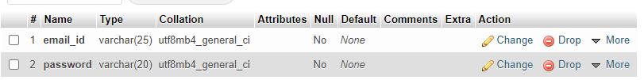

**Table 3.2: USER REGISTRATION DATA**

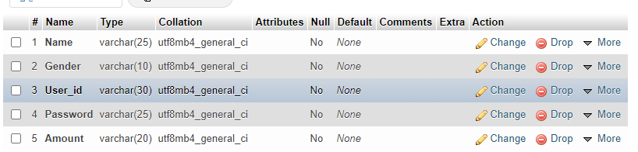

**Table 3.3: TICKET BOOKING DATA**

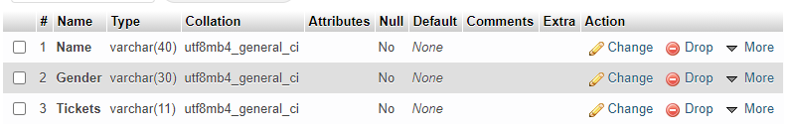

**Table 3.4: VACANT SEATS DATA**



**Table 3.5: USER RATING DATA**

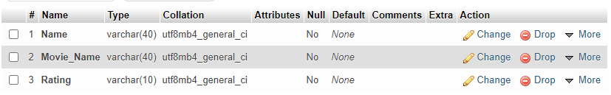

**Table 3.6: USER LIKINGS DATA**

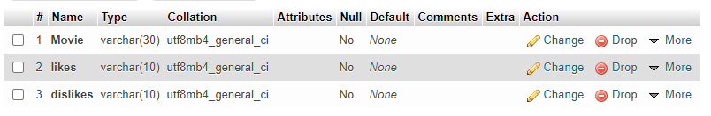

**Table 3.7: USER RECOMMENDED MOVIES**

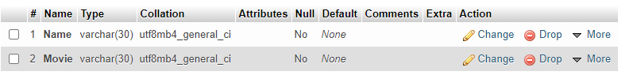

**Table 3.8: USER REVIEWS DATA**

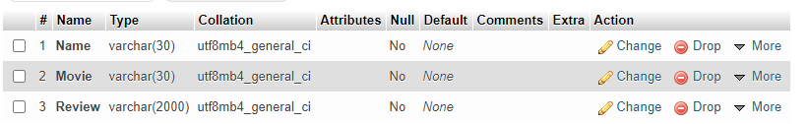

**OUTPUT SCREENS**

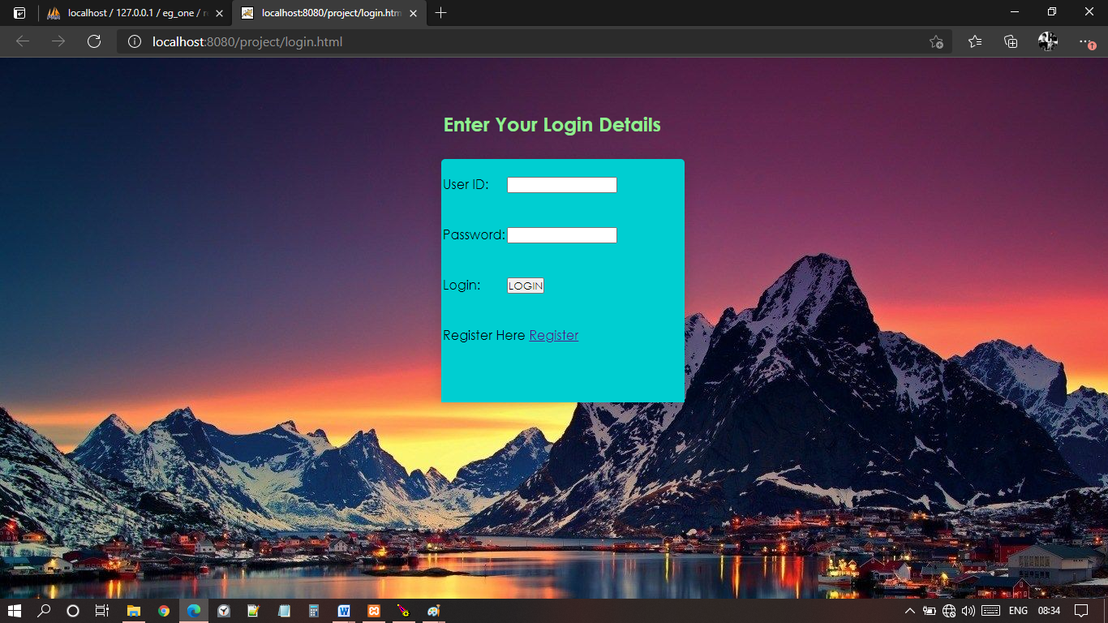

**Fig.4.1: Login Page**

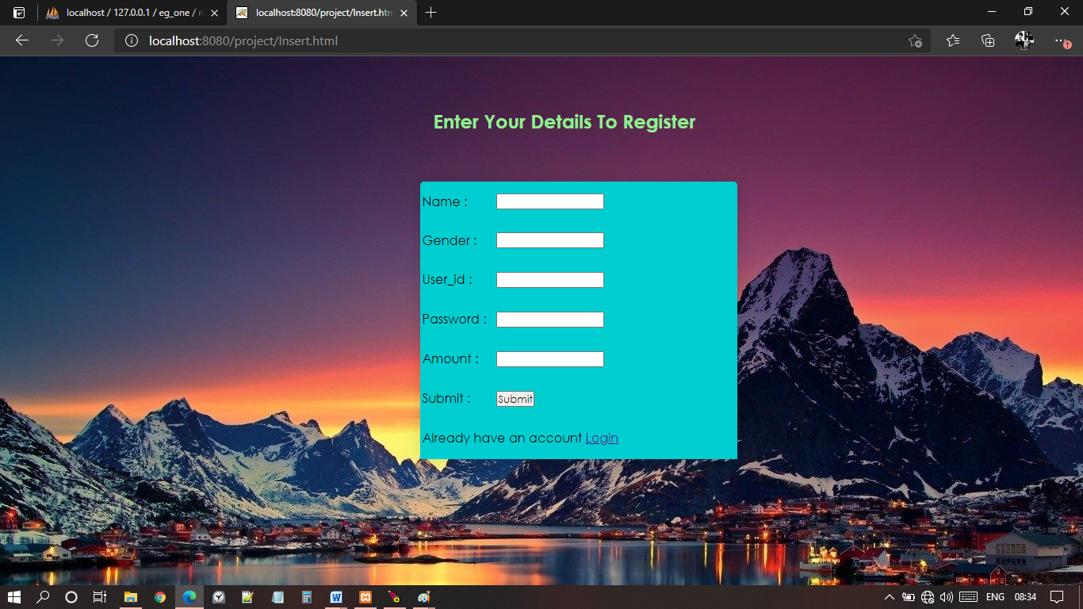

**Fig.4.2: Registration Page**

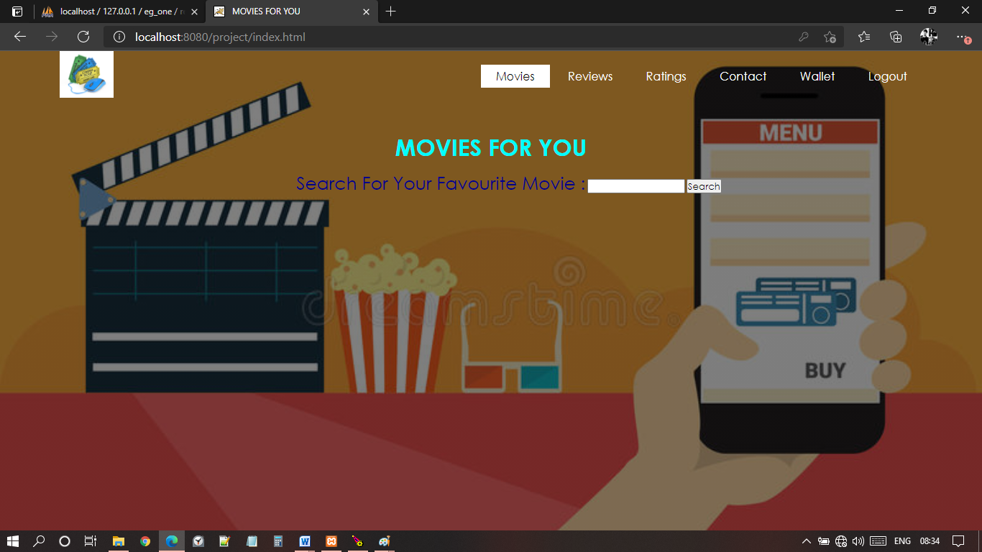

**Fig.4.3: Home Page**

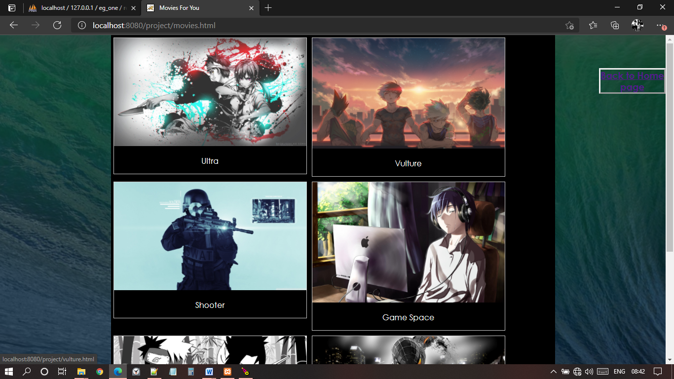

**Fig.4.4: Movies Page**

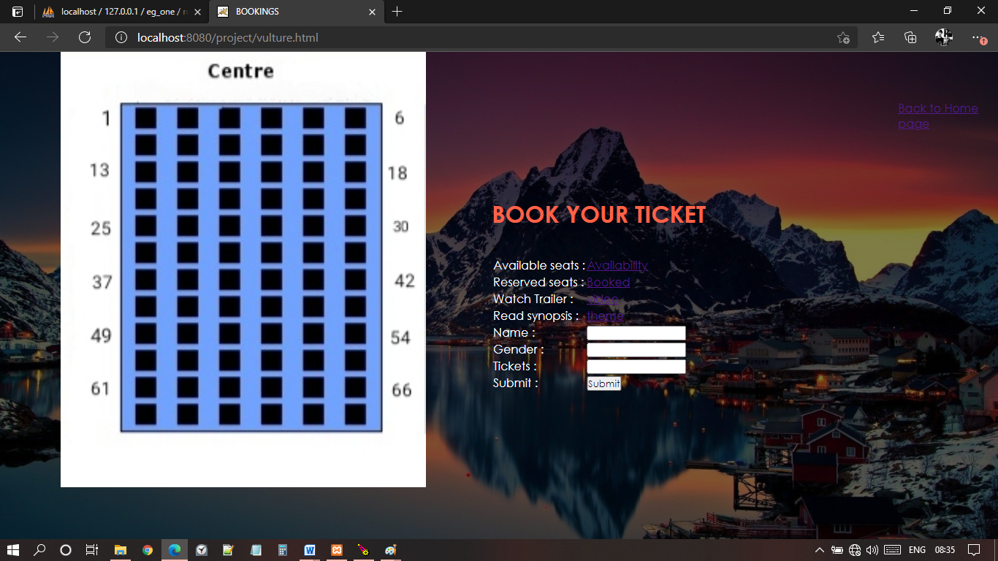

**Fig.4.5: Ticket Booking Page**

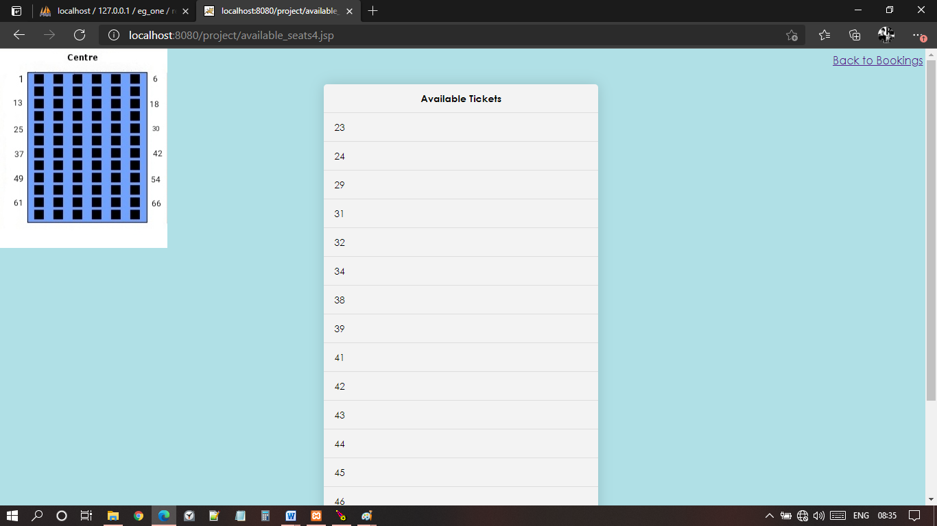

**Fig.4.6: Available Tickets Page**

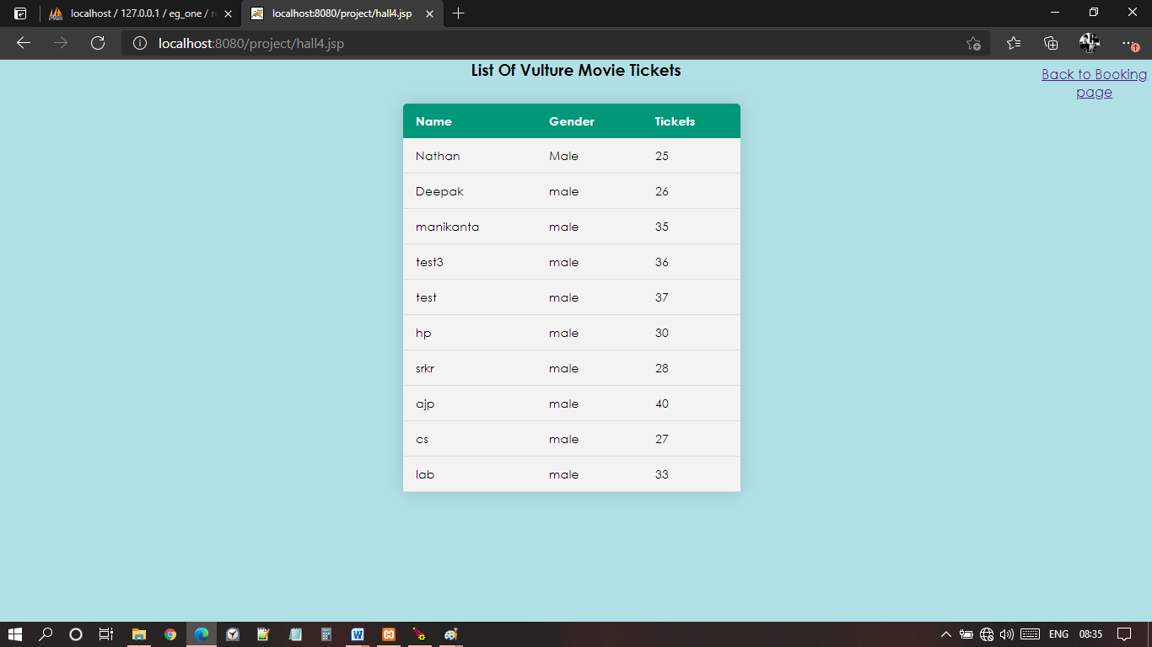

**Fig.4.7: Reserved Tickets Page**

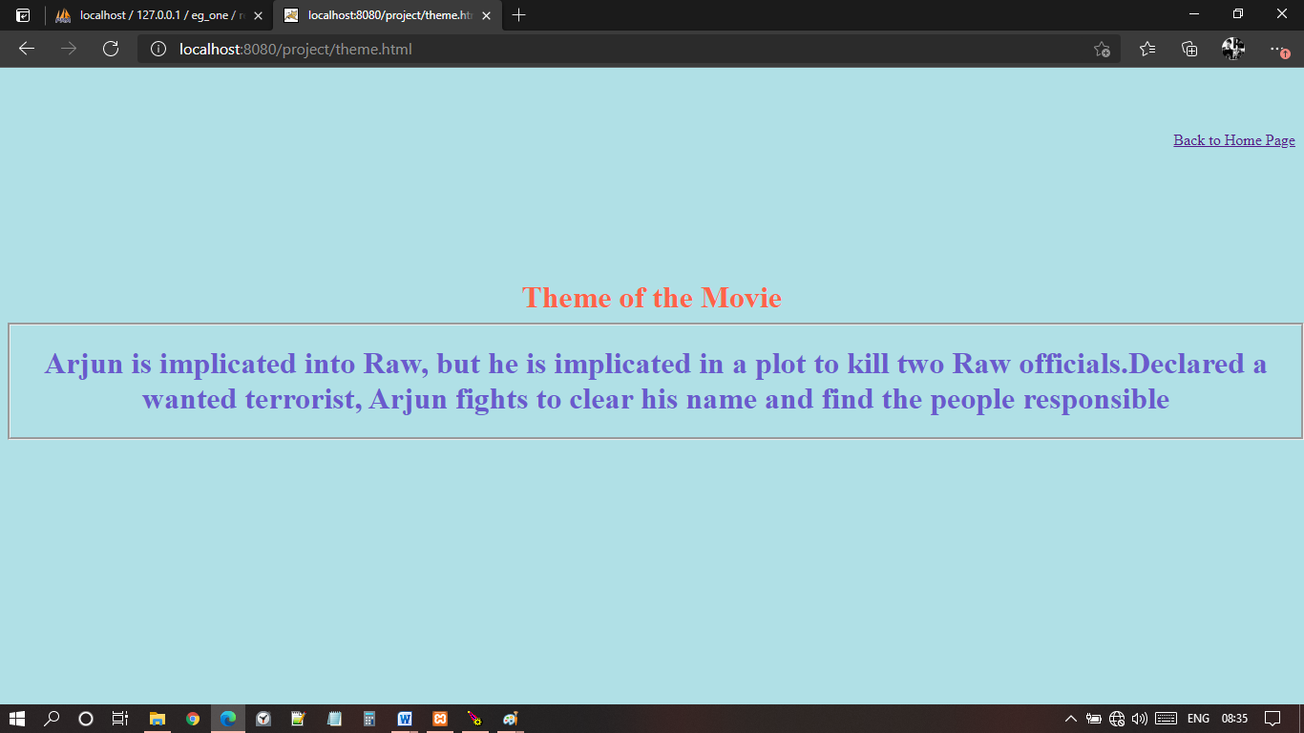

**Fig.4.8: Movie Theme Page**



**Fig.4.9: Movie Trailer Page**

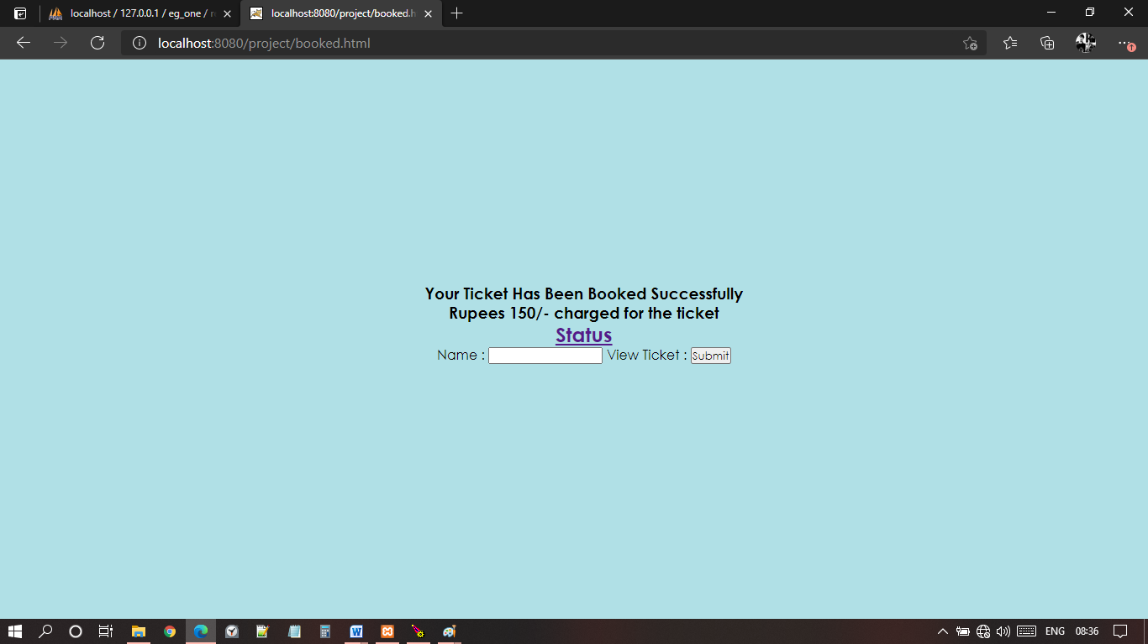

**Fig.4.10: Ticket Status Page**

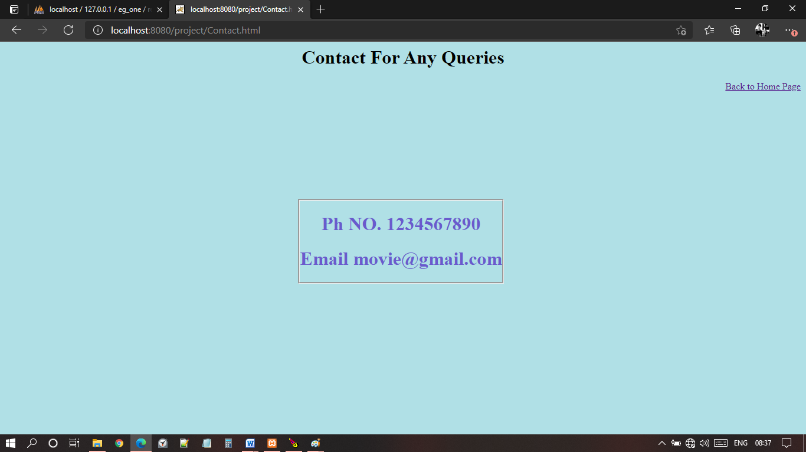

**Fig.4.11: Contact Support Page**

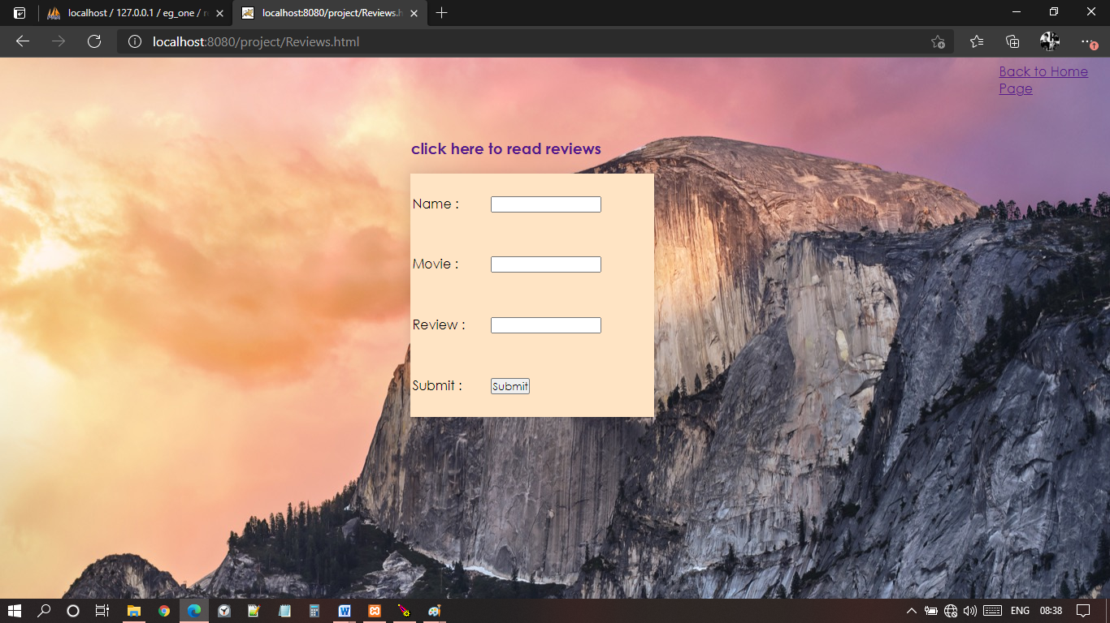

**Fig.4.12: Review Writing Page**

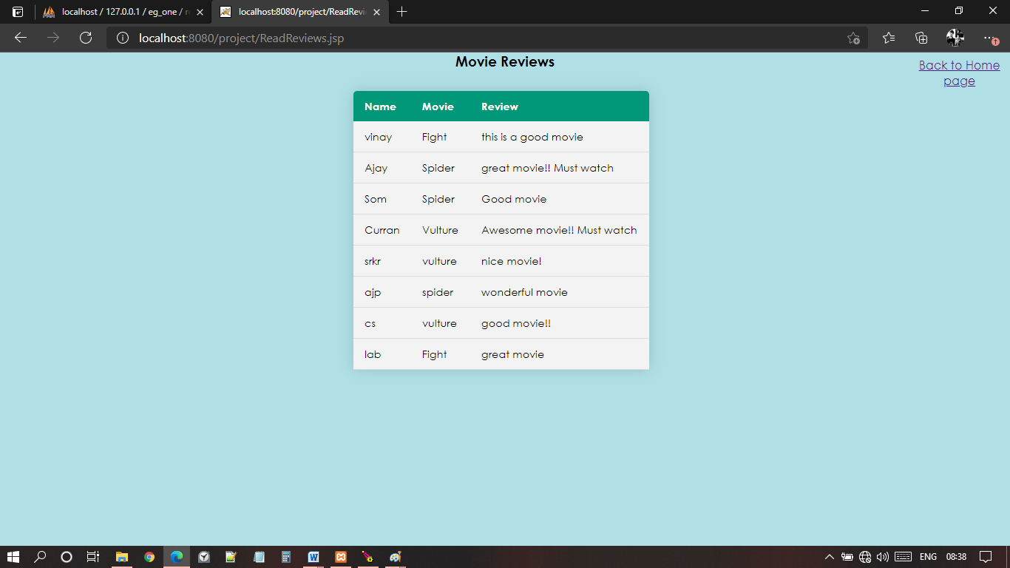

**Fig.4.13: Reviews Page**

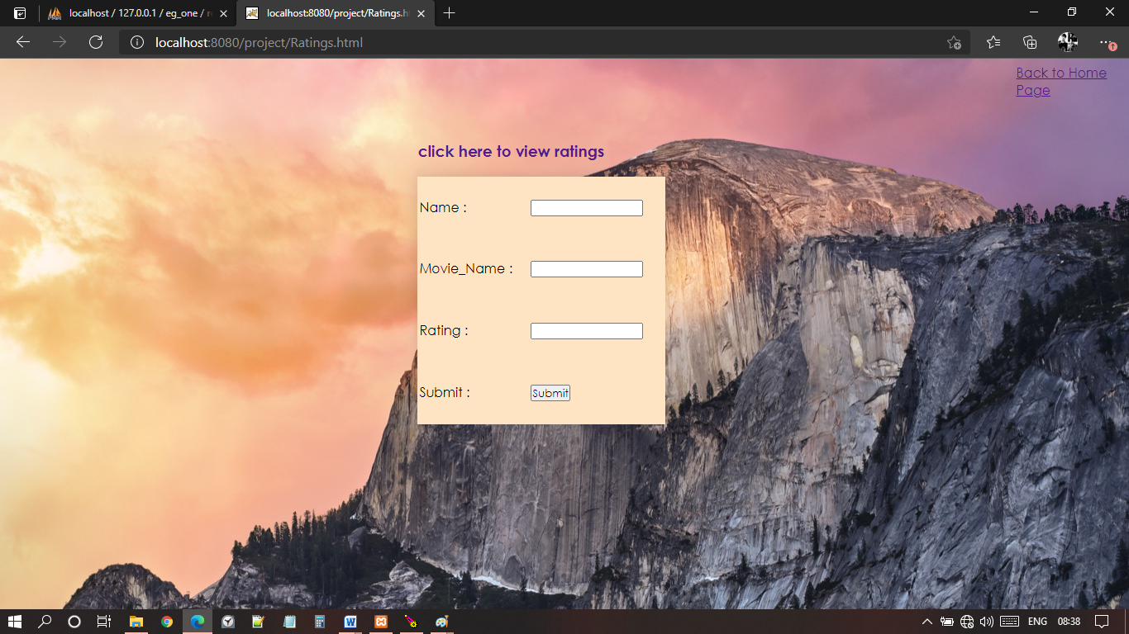

**Fig.4.14: Ratings Page**

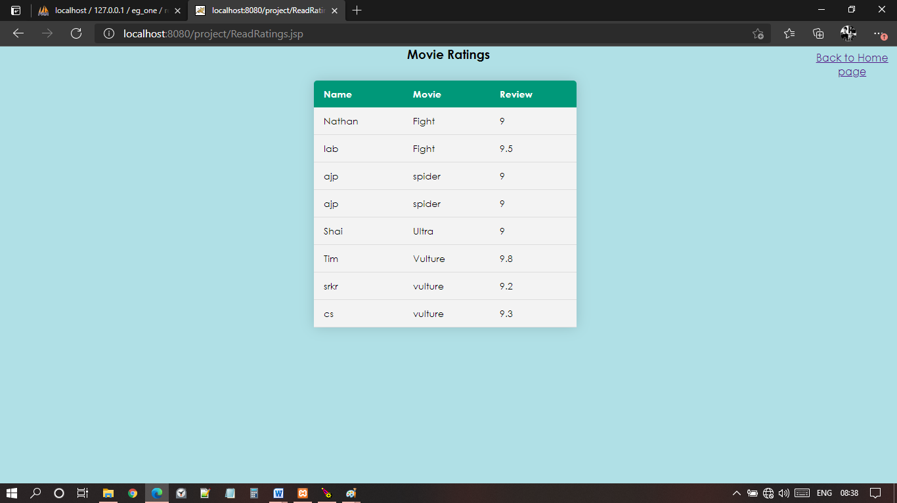

**Fig.4.15: Ratings Page 2**

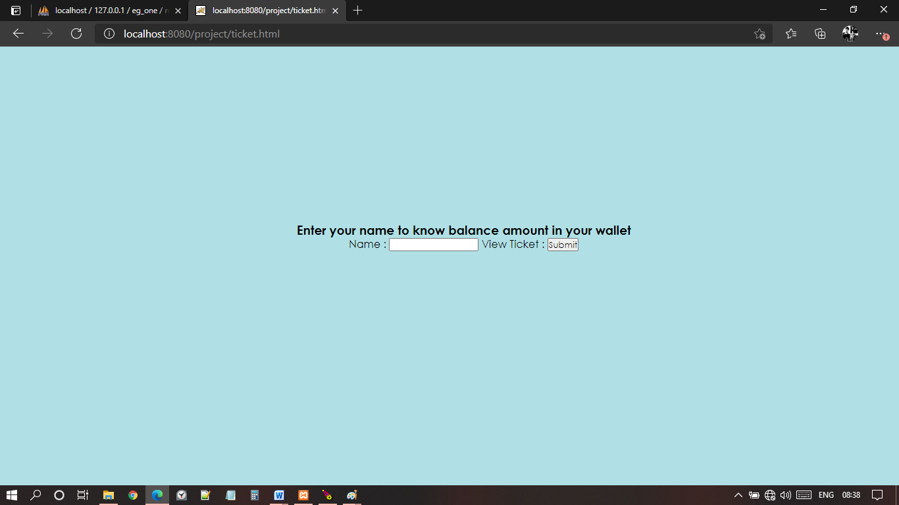

**Fig.4.16: Wallet Page**

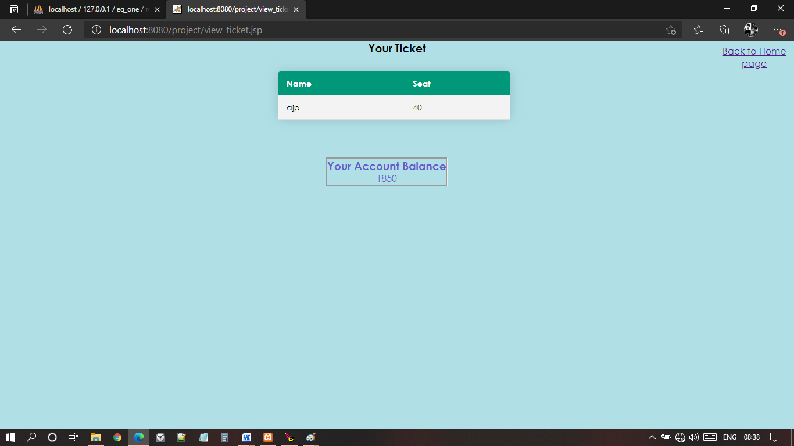

**Fig.4.17: Account Balance Page**

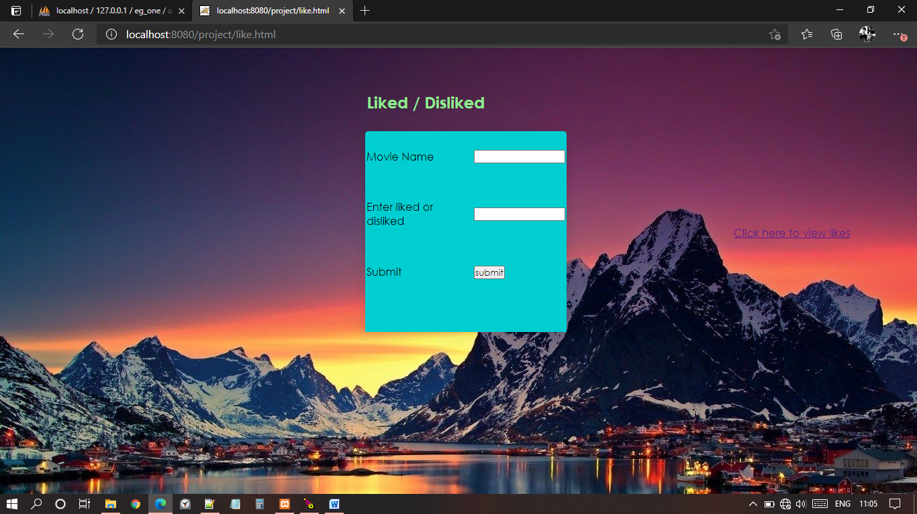

**Fig.4.18: Likings Page**

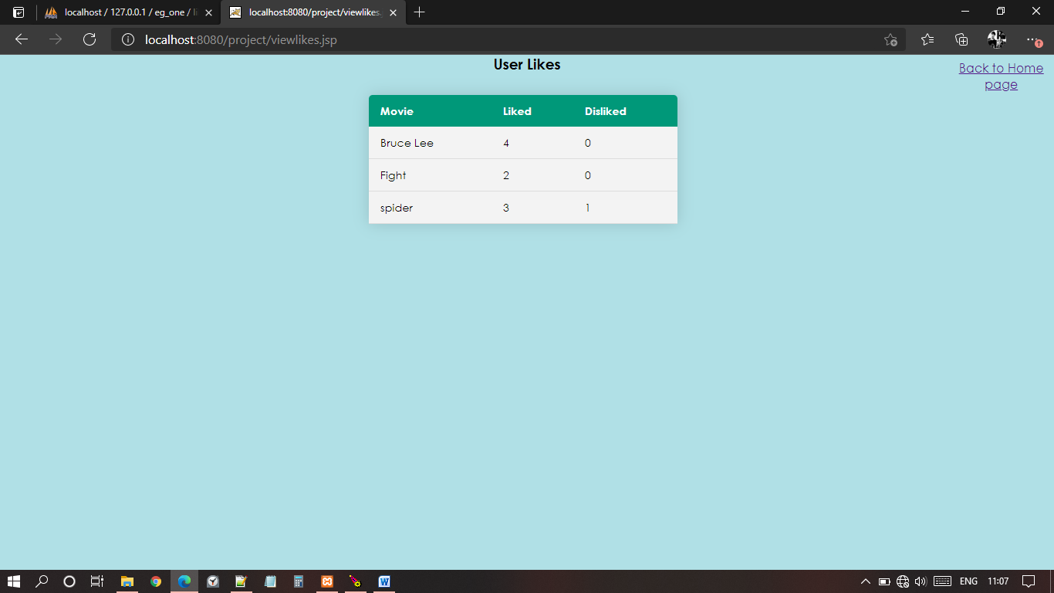

**Fig.4.19: User Likings Page**

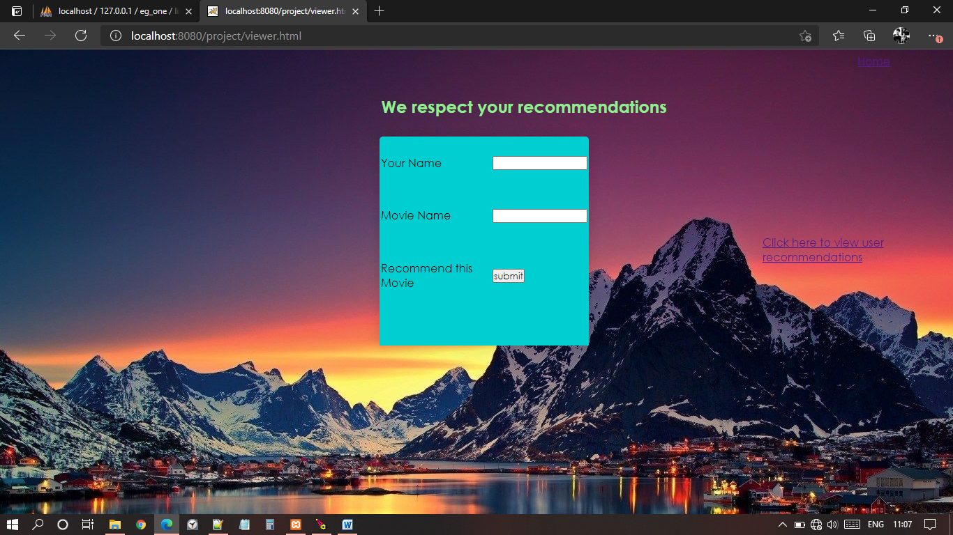

**Fig.4.20: Recommendations Page**

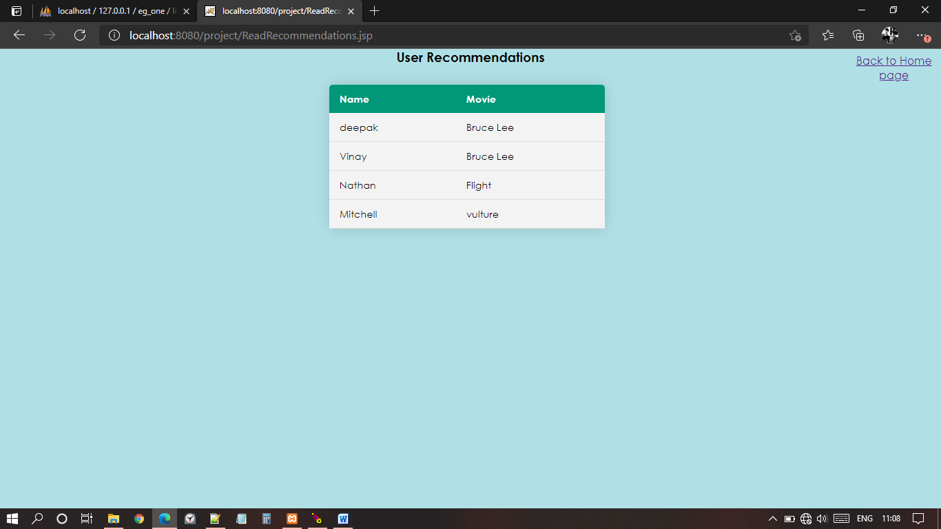

**Fig.4.21: User Recommendations Page**

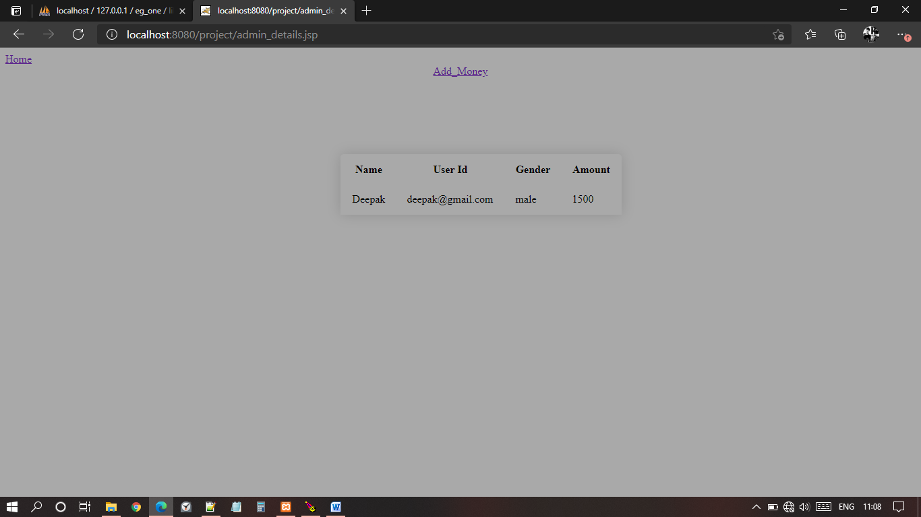

**Fig.4.22: Admin Details Page**

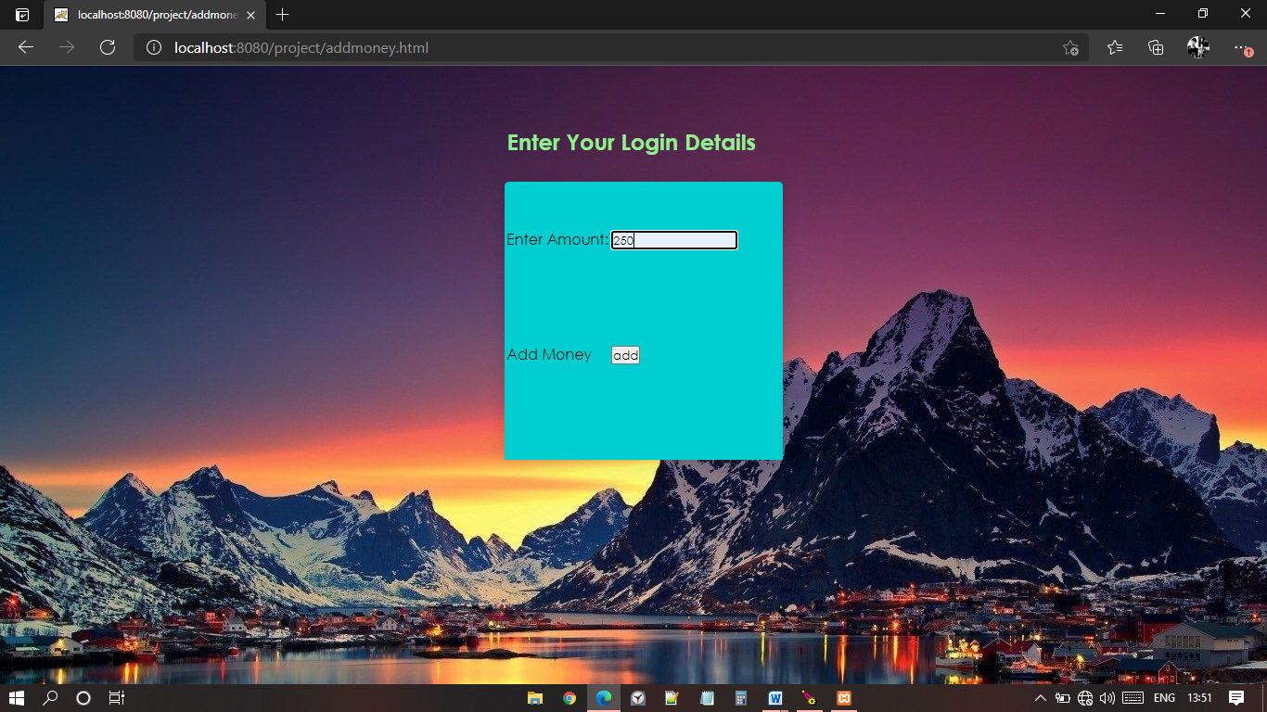

**Fig.4.23: Money Adding Page**

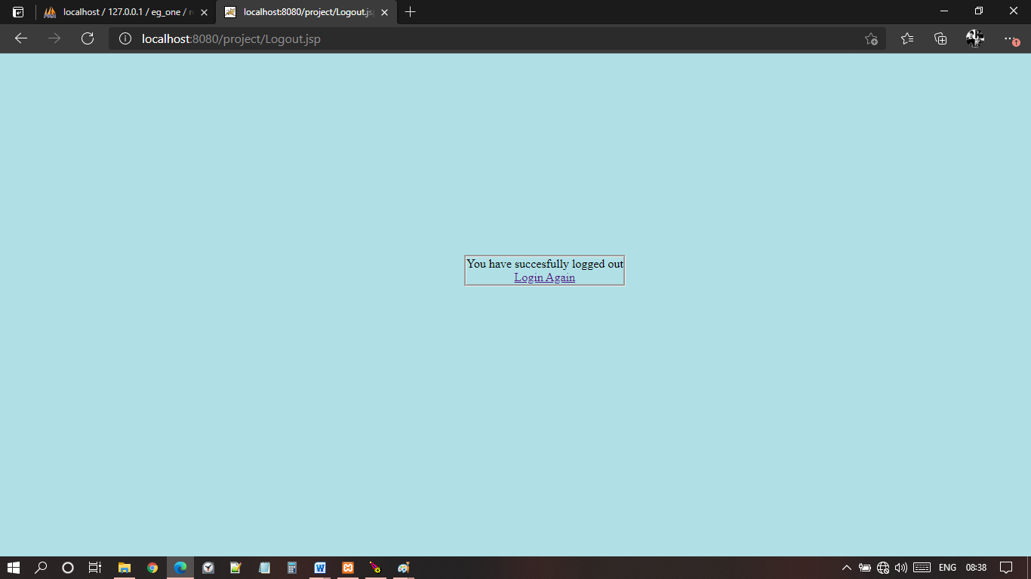

**Fig.4.24: Logout Page**

1. **CODE**

**Insert.html**

<html>

<link rel="stylesheet" type="text/css" href="css/style5.css">

<body background="345330.jpg">

<div class="register_form">

<form name="f1" method="POST" action="Insert.jsp">

<table class=regtab>

<tr>

<td>Name :</td>

<td><input type="text" name="Name"></td>

</tr>

<tr>

<td>Gender :</td>

<td><input type="text" name="Gender"></td>

</tr>

<tr>

<td>User_id :</td>

<td><input type="text" name="User_id"></td>

</tr>

<tr>

<td>Password :</td>

<td><input type="password" name="Password"></td>

</tr>

<tr>

<td>Amount :</td>

<td><input type="number" name="Amount"></td>

</tr>

<tr>

<td>Submit :</td>

<td><input type="submit" name="Insert"></td>

</tr>

<tr>

<td colspan="2">Already have an account <a href="login.html">Login</a></td>

</tr>

</table>

</form>

</div>

<div class="details">

<center>

<h2 style="color:lightgreen">Enter Your Details To Register</h2>

</center>

</div>

</body>

</html>

**Insert.jsp**

<%@ page import="java.io.*" %>

<%@ page import="java.sql.*" %>

<%

try

{

Class.forName("com.mysql.jdbc.Driver");

Connection con = DriverManager.getConnection("jdbc:mysql://localhost:3306/eg_one", "root", "");

String Name=request.getParameter("Name");

String Gender=request.getParameter("Gender");

String User_id=request.getParameter("User_id");

String Password=request.getParameter("Password");

String Amount=request.getParameter("Amount");

PreparedStatement ps=con.prepareStatement("insert into register values(?,?,?,?,?)");

ps.setString(1,Name);

ps.setString(2,Gender);

ps.setString(3,User_id);

ps.setString(4,Password);

ps.setString(5,Amount);

int r=ps.executeUpdate();

if(r==0)

out.println("failure");

else

out.println("Registration Successful");

response.sendRedirect("login.html");

}

catch(Exception e)

{

out.print(e);

e.printStackTrace();

}

%>

**Login.html**

<html>

<body>

<body background="345330.jpg">

<link rel="stylesheet" type="text/css" href="css/style5.css">

<body bgcolor="BurlyWood">

<div class="login_details">

<h2 style="color:lightgreen">Enter Your Login Details</h2>

</div>

<div class="login_form">

<form name="f1" method="POST" action="login.jsp">

<table class="tab">

<tr>

<td>User ID:</td>

<td><input type="text" name="User_id"></td>

</tr>

<tr>

<td>Password:</td>

<td><input type="password" name="Password"></td>

</tr>

<tr>

<td>Login:</td>

<td><input type="submit" value="LOGIN"></td>

</tr>

<tr>

<td colspan="2">Register Here <a href="Insert.html">Register</a></td>

</tr>

</table>

</form>

</div>

</body>

</html>

**Login.jsp**

<%@ page import="java.io.*" %>

<%@ page import="java.sql.*" %>

<%

String User_id=request.getParameter("User_id");

String Password=request.getParameter("Password");

Try

{

Class.forName("com.mysql.jdbc.Driver");

Connection con = DriverManager.getConnection("jdbc:mysql://localhost:3306/eg_one", "root", "");

Statement st=con.createStatement();

ResultSet rs=st.executeQuery("select * from register where User_id='"+User_id+"' and Password='"+Password+"'");

if(rs.next())

{

session.setAttribute("User_id",User_id);

response.sendRedirect("index.html");

}

else

{

response.sendRedirect("loginfailure.html");

}

}

catch(Exception e)

{

out.print(e);

e.printStackTrace();

}

con.close();

%>

**Index.jsp**

<!DOCTYPE html>

<html>

<head>

<title>MOVIES FOR YOU</title>

<link rel="stylesheet" type="text/css" href="css/style.css">

</head>

<body>

<%

response.setHeader("Cache-Control", "no-cache, no-store, must-revalidate");

if(session.getAttribute("User_id")==null)

response.sendRedirect("login.html");

%>

<header>

<div class="main">

<div class="logo">

<img src="movie_pic2.jpg">

</div>

<ul>

<li class="active"><a href="movies.html">Movies</a></li>

<li><a href="Reviews.html">Reviews</a></li>

<li><a href="like.html">Likings</a></li>

<li><a href="Ratings.html">Ratings</a></li>

<li><a href="viewer.html">Recommend</a></li>

<li><a href=Contact.html>Contact</a></li>

<li><a href=ticket.html>Wallet</a></li>

<li><a href=admin_details.jsp>Admin</a></li>

<li><a href=Logout.jsp>Logout</a></li>

</ul>

</div>

<div class="title">

<h1>MOVIES FOR YOU</h1>

</div>

<div class="tab2">

<form name="f1" method="POST" action="search.jsp">

<table>

<tr>

<td>Search For Your Favourite Movie :</td>

<td><input type="text" name="MovieName"></td>

<td><input type="submit" value="Search"></td>

</tr>

</table>

</form>

</div>

</header>

</body>

</html>

**Style1.css**

*{

margin: 0;

padding: 0;

font-family: Century Gothic;

}

.tab {

height: 250px;

}

header{

background-image: linear-gradient(rgba(0,0,0,0.5),rgba(0,0,0,0.5)), url(../movie_pic.jpg);

height: 100vh;

background-size: cover;

background-position: center;

}

ul{

float: right;

list-style-type: none;

margin-top: 25px;

}

ul li{

display: inline-block;

}

ul li a{

text-decoration: none;

color: #fff;

padding: 5px 20px;

border: 1px solid transparent;

transition: 0.6s ease;

}

ul li a:hover{

background-color: #fff;

color: #000;

}

ul li.active a{

background-color: #fff;

color: #000;

}

.logo img{

float: left;

width: 75px;

height: auto;

}

.main{

max-width: 1200px;

margin: auto;

}

.title{

color: #fff;

position: absolute;

color: cyan;

top: 20%;

left: 50%;

transform: translate(-50%,-50%);

}

.tab2{

position: absolute;

color: darkblue;

font-size: 25px;

top: 25%;

left: 30%

}

**Style2.css**

*{

margin: 0;

padding: 0;

font-family: Century Gothic;

}

header{

background-image: linear-gradient(rgba(0,0,0,0.5),rgba(0,0,0,0.5)), url(../345330.jpg);

height: 100vh;

background-size: cover;

background-position: center;

}

ul{

float: right;

list-style-type: none;

margin-top: 25px;

}

.Home{

position: absolute;

top: 90%;

left: 10%;

}

.logo img{

float: center;

width: 500px;

height: auto;

}

.main{

max-width: 1200px;

margin: auto;

}

.title{

color: #fff;

position: absolute;

top: 50%;

left: 60%;

transform: translate(-50%,-50%);

}

.Home{

position: absolute;

top: 10%;

left: 90%;

}

**Style3.css**

.numbers{

border-style: groove;

color: slateblue;

position: absolute;

top: 40%;

left: 37%;

}

.Queries{

text-align: center;

top: 40%;

}

.Home{

position: absolute;

top: 10%;

left: 90%;

}

.theme{

position: absolute;

color: tomato;

top: 30%;

left: 40%;

}

.theme2{

border-style: groove;

color: slateblue;

position: absolute;

top: 40%;

}

**Movies.html**

<!DOCTYPE html>

<html>

<head>

<title>

Movies For You

</title>

<link rel="stylesheet" href="css/style3.css">

</head>

<body>

<header>

<div class="container">

<div class="gallery">

<a href="Bookings.html"><img src="movie1.jpg"></a>

<div class="desc">Ultra</div>

</div>

<div class="gallery">

<a href="vulture.html"><img src="movie4.jpg"></a>

<div class="desc">Vulture</div>

</div>

<div class="gallery">

<a href="vulture.html"><img src="movie5.jpg"></a>

<div class="desc">Shooter</div>

</div>

<div class="gallery">

<a href="vulture.html"><img src="movie62.jpg"></a>

<div class="desc">Game Space</div>

</div>

<div class="gallery">

<a href="Bookings3.html"><img src="movie3.jpeg"></a>

<div class="desc">Fight</div>

</div>

<div class="gallery">

<a href="Bookings2.html"><img src="movie2.jpeg"></a>

<div class="desc">Spider</div>

</div>

</div>

</header>

<center>

<div class="Home">

<h3><a href=index.html>Back to Home page</a></h3>

</div>

</center>

</body>

</html>

**Search.jsp**

<%@ page import="java.sql.*" %>

<html>

<body style="background-color: powderblue;">

<center>

<%

try {

Class.forName("com.mysql.jdbc.Driver");

Connection con = DriverManager.getConnection("jdbc:mysql://localhost:3306/eg_one", "root", "");

Statement st=con.createStatement();

String MovieName = request.getParameter("MovieName");

String vulture = "vulture";

String vulture2 = "spider";

if(MovieName.equals(vulture) || MovieName.equals(vulture2))

{

response.sendRedirect(" "+MovieName+".html ");

}

else

{

out.print("The Movie you have entered is not available");

}

}

catch(Exception e)

{

out.print(e);

e.printStackTrace();

}

%>

<div class="Home">

<a href=index.html>Back to Home page</a>

</div>

</center>

</body>

</html>

**Vulture.html**

<!DOCTYPE html>

<html>

<form name="f1" method="POST" action="vulture.jsp">

<head>

<title>BOOKINGS</title>

<link rel="stylesheet" type="text/css" href="css/style2.css">

</head>

<body>

<header>

<div class="main">

<div class="logo">

<img src="seats.jpg">

<div class="title">

<h1 style="color:tomato;">BOOK YOUR TICKET </h1>

<h1 style="color:black;">.</h1>

<table>

<tr>

<td>Available seats :</td>

<td><a href=available_seats4.jsp>Availability</a></td>

</tr>

<td>Reserved seats :</td>

<td><a href=hall4.jsp>Booked</a></td>

</tr>

</tr>

<td>Watch Trailer :</td>

<td><a href=hall4video.html>video</a></td>

</tr>

<tr>

<td>Read synopsis :</td>

<td><a href=theme.html>theme</a></td>

</tr>

<tr>

<td>Name :</td>

<td><input type="text" name="Name"></td>

</tr>

<tr>

<td>Gender :</td>

<td><input type="text" name="Gender"></td>

</tr>

<tr>

<td>Tickets :</td>

<td><input type="number" name="Tickets"></td>

</tr>

<tr>

<td>Submit :</td>

<td><input type="submit" name="Submit"></td>

</tr>

</table>

</div>

</header>

<div class="Home">

<a href=index.html>Back to Home page</a>

</div>

</form>

</body>

</html>

**Vulture.jsp**

<%@ page import="java.io.*" %>

<%@ page import="java.sql.*" %>

<%

Class.forName("com.mysql.jdbc.Driver");

Connection con = DriverManager.getConnection("jdbc:mysql://localhost:3306/eg_one", "root", "");

String Name=request.getParameter("Name");

String Gender=request.getParameter("Gender");

String Tickets=request.getParameter("Tickets");

PreparedStatement pss=con.prepareStatement("insert into hall4 values(?,?,?)");

pss.setString(1,Name);

pss.setString(2,Gender);

pss.setString(3,Tickets);

int rr=pss.executeUpdate();

Statement st=con.createStatement();

ResultSet rs=st.executeQuery("select * from register where Name='"+Name+"'");

while(rs.next())

{

String a = rs.getString("Amount");

int b = Integer.parseInt(a);

b=b-150;

String c = String.valueOf(b);

PreparedStatement psa=con.prepareStatement("update register SET Amount = '"+c+"' where Name='"+Name+"'");

int r=psa.executeUpdate();

}

PreparedStatement ps=con.prepareStatement("delete from movies4 where Tickets=?");

ps.setString(1,Tickets);

int r=ps.executeUpdate();

if(r==0)

{

%>

Ticket Booking Failed

<%

}

else

{

response.sendRedirect("booked.html");

}

con.close();

%>

**Available_seats.jsp**

<%@ page import="java.sql.*" %>

<html>

<head>

<body style="background-color:powderblue;">

<link rel="stylesheet" type="text/css" href="css/style4.css">

</head>

<table class="content-table">

<tr>

<th>Available Tickets</th>

</tr>

<%

Class.forName("com.mysql.jdbc.Driver");

Connection con = DriverManager.getConnection("jdbc:mysql://localhost:3306/eg_one", "root", "");

String id=request.getParameter("");

Statement st=con.createStatement();

ResultSet rs=st.executeQuery("select * from movies4");

while(rs.next())

{

%>

<tr>

<td><%=rs.getString("Tickets") %> </td>

</tr>

<%

}

con.close();

%>

<div class="Home">

<a href=vulture.html>Back to Bookings</a>

</div>

<img src="seats.jpg">

</table>

</body>

</html>

**Cinema_hall.jsp**

<%@ page import="java.sql.*" %>

<html>

<body style="background-color:powderblue;">

<link rel="stylesheet" type="text/css" href="css/style4.css">

<center>

<h3 style="color:black">List Of Vulture Movie Tickets</h3>

<table class="content-table">

<thead>

<tr>

<th>Name</th>

<th>Gender</th>

<th>Tickets</th>

</tr>

</thead>

<%

Class.forName("com.mysql.jdbc.Driver");

Connection con = DriverManager.getConnection("jdbc:mysql://localhost:3306/eg_one", "root", "");

String s1=request.getParameter("Name");

Statement st=con.createStatement();

ResultSet rs=st.executeQuery("select * from hall4 ");

while(rs.next())

{

%>

<tr>

<td><%=rs.getString("Name") %> </td>

<td><%=rs.getString("Gender") %> </td>

<td><%=rs.getString("Tickets") %> </td>

</tr>

<%

}

con.close();

%>

<div class="Home">

<a href=Bookings4.html>Back to Booking page</a>

</div>

</center>

</table>

</body>

</html>

**Trailer.html**

<html>

<link rel="stylesheet" type="text/css" href="css/t.css">

<center>

<body style="background-color: CadetBlue;">

<video width="1080" height="auto" controls>

<source src="Extraction.mp4" type="video/mp4">

<source src="Extraction.ogg" type="video/ogg">

</video>

</center>

<center>

<div class="Home">

<a href=Bookings4.html>Back to Bookings</a>

</div>

</center>

</body>

</html>

**Ticket_booked.html**

<html>

<link rel="stylesheet" type="text/css" href="css/style4.css">

<head>

</head>

<body style="background-color:powderblue;">

<div class="booked">

<h3>

Your Ticket Has Been Booked Successfully

</h3>

<h3>

Rupees 150/- charged for the ticket

</h3>

<e-ticket sent to your registered email address>

<h2><a href=hall4.jsp>Status</a></h2>

<form name="f1" method="POST" action="view_ticket.jsp">

<tr>

<td>Name :</td>

<td><input type="text" name="Name"></td>

</tr>

<tr>

<td>View Ticket :</td>

<td><input type="submit" name="view"></td>

</tr>

</div>

</body>

**View_ticket.jsp**

<%@ page import="java.sql.*" %>

<html>

<body style="background-color:powderblue;">

<link rel="stylesheet" type="text/css" href="css/style4.css">

<center>

<h3>Your Ticket</h3>

<table class="content-table">

<thead>

<tr>

<th>Name</th>

<th>Seat</th>

</tr>

</thead>

<%

Class.forName("com.mysql.jdbc.Driver");

Connection con = DriverManager.getConnection("jdbc:mysql://localhost:3306/eg_one", "root", "");

String Name=request.getParameter("Name");

Statement st=con.createStatement();

ResultSet rs=st.executeQuery("select * from hall4 where Name='"+Name+"'");

while(rs.next())

{

%>

<tr>

<td><%=rs.getString("Name") %> </td>

<td><%=rs.getString("Tickets") %> </td>

</tr>

<%

}

Statement st2=con.createStatement();

ResultSet rs2=st2.executeQuery("select * from register where Name='"+Name+"'");

while(rs2.next())

{

%>

<div class="new">

<h3>Your Account Balance</h3>

<%=rs2.getString("Amount") %>

</div>

<%

}

con.close();

%>

<div class="Home">

<a href=index.html>Back to Home page</a>

</div>

</center>

</table>

</body>

</html>

**Like.html**

<html>

<body>

<body background="345330.jpg">

<link rel="stylesheet" type="text/css" href="css/style5.css">

<body bgcolor="BurlyWood">

<div class="login_details">

<h2 style="color:lightgreen">Liked / Disliked</h2>

</div>

<div class="login_form">

<form name="f1" method="POST" action="like.jsp">

<table class="tab">

<tr>

<td>Movie Name</td>

<td><input type="text" name="moviename"></td>

</tr>

<tr>

<td>Enter liked or disliked</td>

<td><input type="text" name="liked"></td>

</tr>

<tr>

<td>Submit</td>

<td><input type="submit" value="submit"></td>

</tr>

</table>

</form>

</div>

<div class="read">

<a href=viewlikes.jsp>Click here to view likes</a>

</read>

</body>

</html>

**Like.jsp**

<%@ page import="java.io.*" %>

<%@ page import="java.sql.*" %>

<%

Class.forName("com.mysql.jdbc.Driver");

Connection con = DriverManager.getConnection("jdbc:mysql://localhost:3306/eg_one", "root", "");

String moviename=request.getParameter("moviename");

String like = request.getParameter("liked");

int cc = 1;

String one="liked";

String two="disliked";

Statement st=con.createStatement();

ResultSet rs=st.executeQuery("select * from liker where Movie='"+moviename+"'");

while(rs.next())

{

cc=2;

String s = rs.getString("likes");

int n = Integer.parseInt(s);

String t = rs.getString("dislikes");

int m = Integer.parseInt(t);

if(like.equals(one))

{

int nn=n+1;

String ccc = String.valueOf(nn);

PreparedStatement psa=con.prepareStatement("update liker SET likes = '"+ccc+"' where Movie='"+moviename+"'");

int r=psa.executeUpdate();

}

if(like.equals(two))

{

int mm=m+1;

String cccc = String.valueOf(mm);

PreparedStatement psaa=con.prepareStatement("update liker SET dislikes = '"+cccc+"' where Movie='"+moviename+"'");

int r=psaa.executeUpdate();

}

}

if(cc==1)

{

PreparedStatement pss=con.prepareStatement("insert into liker values(?,?,?)");

pss.setString(1,moviename);

pss.setString(2,"0");

pss.setString(3,"0");

int rr=pss.executeUpdate();

if(like.equals(one))

{

PreparedStatement psa=con.prepareStatement("update liker SET likes = '1' where Movie='"+moviename+"'");

int r=psa.executeUpdate();

}

if(like.equals(two))

{

PreparedStatement psaa=con.prepareStatement("update liker SET dislikes = '1' where Movie='"+moviename+"'");

int r=psaa.executeUpdate();

}

}

response.sendRedirect("viewlikes.html");

con.close();

%>

**Viewlikes.html**

<html>

<head>

</head>

<body style="background-color: powderblue;">

</center>

<a href=viewlikes.jsp>Click here to view </a>

</center>

</body>

</html>

**Viewlikes.jsp**

<%@ page import="java.sql.*" %>

<html>

<body style="background-color:powderblue;">

<link rel="stylesheet" type="text/css" href="css/style4.css">

<center>

<h3>User Likes</h3>

<table class="content-table">

<thead>

<tr>

<th>Movie</th>

<th>Liked</th>

<th>Disliked</th>

</tr>

</thead>

<%

Class.forName("com.mysql.jdbc.Driver");

Connection con = DriverManager.getConnection("jdbc:mysql://localhost:3306/eg_one", "root", "");

String id=request.getParameter("");

Statement st=con.createStatement();

ResultSet rs=st.executeQuery("select * from liker ORDER BY Movie;");

while(rs.next())

{

%>

<tr>

<td><%=rs.getString("Movie") %> </td>

<td><%=rs.getString("likes") %> </td>

<td><%=rs.getString("dislikes") %> </td>

</tr>

<%

}

con.close();

%>

<div class="Home">

<a href=index.jsp>Back to Home page</a>

</div>

</center>

</table>

</body>

</html>

**Recommend.jsp**

<%@ page import="java.io.*" %>

<%@ page import="java.sql.*" %>

<%

try

{

Class.forName("com.mysql.jdbc.Driver");

Connection con = DriverManager.getConnection("jdbc:mysql://localhost:3306/eg_one", "root", "");

String YName=request.getParameter("YName");

String MName=request.getParameter("MName");

int i=1;

Statement st=con.createStatement();

ResultSet rs=st.executeQuery("select Name from recommendations where Name = '"+YName+"'");

while(rs.next())

{

i=2;

response.sendRedirect("viewer.html");

}

if(i==1)

{

PreparedStatement ps=con.prepareStatement("insert into recommendations values(?,?)");

ps.setString(1,YName);

ps.setString(2,MName);

int r=ps.executeUpdate();

if(r==0)

out.println("failure");

else

out.println("Recommendation Successful");

}

}

catch(Exception e)

{

out.print(e);

}

%>

**Readrecommendations.jsp**

<%@ page import="java.sql.*" %>

<html>

<body style="background-color:powderblue;">

<link rel="stylesheet" type="text/css" href="css/style4.css">

<center>

<h3>User Recommendations</h3>

<table class="content-table">

<thead>

<tr>

<th>Name</th>

<th>Movie</th>

</tr>

</thead>

<%

try {

Class.forName("com.mysql.jdbc.Driver");

Connection con = DriverManager.getConnection("jdbc:mysql://localhost:3306/eg_one", "root", "");

String id=request.getParameter("");

Statement st=con.createStatement();

ResultSet rs=st.executeQuery("select * from recommendations ORDER BY Movie");

while(rs.next())

{

%>

<tr>

<td><%=rs.getString("Name") %> </td>

<td><%=rs.getString("Movie") %> </td>

</tr>

<%

}

}

catch(Exception e)

{

out.print(e);

e.printStackTrace();

}

con.close();

%>

<div class="Home">

<a href=index.jsp>Back to Home page</a>

</div>

</center>

</table>

</body>

</html>

**Addmoney.html**

<html>

<body>

<body background="345330.jpg">

<link rel="stylesheet" type="text/css" href="css/style5.css">

<body bgcolor="BurlyWood">

<div class="login_details">

<h2 style="color:lightgreen">Enter Your Login Details</h2>

</div>

<div class="login_form">

<form name="f1" method="POST" action="addmoney.jsp">

<table class="tab">

<tr>

<td>Enter Amount:</td>

<td><input type="text" name="add"></td>

</tr>

<tr>

<td>Add Money</td>

<td><input type="submit" value="add"></td>

</tr>

</table>

</form>

</div>

</body>

</html>

**Addmoney.jsp**

<%@ page import="java.io.*" %>

<%@ page import="java.sql.*" %>

<%

Class.forName("com.mysql.jdbc.Driver");

Connection con = DriverManager.getConnection("jdbc:mysql://localhost:3306/eg_one", "root", "");

String id=session.getAttribute("User_id").toString();

String add = request.getParameter("add");

Statement st=con.createStatement();

ResultSet rs=st.executeQuery("select * from register where User_id='"+id+"'");

while(rs.next())

{

String a = rs.getString("Amount");

int b = Integer.parseInt(a);

int k = Integer.parseInt(add);

int added=b+k;

String c = String.valueOf(added);

PreparedStatement psa=con.prepareStatement("update register SET Amount = '"+c+"' where User_id='"+id+"'");

int r=psa.executeUpdate();

}

response.sendRedirect("addsuccess.html");

con.close();

%>

**Admin_details.jsp**

<%@ page import="java.sql.*" %>

<html>

<link rel="stylesheet" type="text/css" href="css/admindetails.css">

<body bgcolor="darkgrey">

<a href="index.jsp">Home</a>

<center>

<div class="admindetails">

<table>

<tr>

<th>Name</th>

<th>User Id</th>

<th>Gender</th>

<th>Amount</th>

</tr>

<%

Class.forName("com.mysql.jdbc.Driver");

Connection con = DriverManager.getConnection("jdbc:mysql://localhost:3306/eg_one", "root", "");

String id= session.getAttribute("User_id").toString();

Statement st=con.createStatement();

ResultSet rs=st.executeQuery("select * from register where User_id='"+id+"' ");

while(rs.next()) {

%>

<tr>

<td><%=rs.getString("Name") %> </td>

<td><%=rs.getString("User_id") %> </td>

<td><%=rs.getString("Gender") %> </td>

<td><%=rs.getString("Amount") %> </td>

</tr>

<%

}

con.close();

%>

</center>

</table>

</div>

<a href="addmoney.html">Add_Money</a>

</body>

</html>

**Wallet.html**

<html>

<link rel="stylesheet" type="text/css" href="css/style4.css">

<head>

</head>

<body style="background-color:powderblue;">

<div class="booked2">

<h3>

Enter your name to know balance amount in your wallet

</h3>

<form name="f1" method="POST" action="view_ticket.jsp">

<tr>

<td>Name :</td>

<td><input type="text" name="Name"></td>

</tr>

<tr>

<td>View Ticket :</td>

<td><input type="submit" name="view"></td>

</tr>

</div>

</body>

</html>

**Ratings.html**

<!DOCTYPE html>

<html>

<link rel="stylesheet" href="css/style5.css">

<body background="10-10--thumb.jpg">

<div class="reviews">

<form name="f1" method="POST" action="Ratings.jsp">

<table class="reviews_table">

<tr>

<td>Name :</td>

<td><input type="text" name="Name"></td>

</tr>

<tr>

<td>Movie_Name :</td>

<td><input type="text" name="Movie_Name"></td>

</tr>

<tr>

<td>Rating :</td>

<td><input type="text" name="Rating"></td>

</tr>

<tr>

<td>Submit :</td>

<td><input type="submit" name="Submit"></td>

</tr>

</table>

</form>

</div>

<a href="ReadRatings.jsp">

<div class="reviews2">

<h3>click here to view ratings

</h3>

</div>

</a>

<div class="Home">

<a href=index.html>Back to Home Page</a>

</div>

</body>

</html>

**Ratings.jsp**

<%@ page import="java.io.*" %>

<%@ page import="java.sql.*" %>

<%

Class.forName("com.mysql.jdbc.Driver");

Connection con = DriverManager.getConnection("jdbc:mysql://localhost:3306/eg_one", "root", "");

String Name=request.getParameter("Name");

String Movie=request.getParameter("Movie_Name");

String Review=request.getParameter("Rating");

PreparedStatement ps=con.prepareStatement("insert into Ratings values(?,?,?)");

ps.setString(1,Name);

ps.setString(2,Movie);

ps.setString(3,Review);

int r=ps.executeUpdate();

if(r==0)

out.println("failure");

else

response.sendRedirect("RatingReceived.html");

con.close();

%>

**RatingReceived.html**

<html>

<link rel="stylesheet" type="text/css" href="css/ReviewReceived.css">

<head>

<div class="Rating">

<center>

<h1>Thank you</h1>

</center>

</head>

<body style="background-color: powderblue;">

<center>

<h2>Your Rating has been received successfully </h2>

</center>

</div>

<div class="ReviewReceived">

<a href="index.html">Back to Home Page</a>

</div>

</body>

</html>

**ReadRatings.jsp**

<%@ page import="java.sql.*" %>

<html>

<body style="background-color:powderblue;">

<link rel="stylesheet" type="text/css" href="css/style4.css">

<center>

<h3>Movie Ratings</h3>

<table class="content-table">

<thead>

<tr>

<th>Name</th>

<th>Movie</th>

<th>Review</th>

</tr>

</thead>

<%

Class.forName("com.mysql.jdbc.Driver");

Connection con = DriverManager.getConnection("jdbc:mysql://localhost:3306/eg_one", "root", "");

String id=request.getParameter("");

Statement st=con.createStatement();

ResultSet rs=st.executeQuery("select * from Ratings order by Movie_Name");

while(rs.next()) {

%>

<tr>

<td><%=rs.getString("Name") %> </td>

<td><%=rs.getString("Movie_Name") %> </td>

<td><%=rs.getString("Rating") %> </td>

</tr>

<%

}

con.close();

%>

<div class="Home">

<a href=index.html>Back to Home page</a>

</div>

</center>

</table>

</body>

</html>

**Reviews.html**

<!DOCTYPE html>

<html>

<link rel="stylesheet" href="css/style5.css">

<body background="10-10--thumb.jpg">

<div class="reviews">

<form name="f1" method="POST" action="Reviews.jsp">

<table class="reviews_table">

<tr>

<td>Name :</td>

<td><input type="text" name="Name"></td>

</tr>

<tr>

<td>Movie :</td>

<td><input type="text" name="Movie"></td>

</tr>

<tr>

<td>Review :</td>

<td><input type="text" name="Review"></td>

</tr>

<tr>

<td>Submit :</td>

<td><input type="submit" name="Submit"></td>

</tr>

</table>

</form>

</div>

<a href="ReadReviews.jsp">

<div class="reviews2">

<h3>click here to read reviews

</h3>

</div>

</a>

<div class="Home">

<a href=index.html>Back to Home Page</a>

</div>

</body>

</html>

**Reviews.jsp**

<%@ page import="java.io.*" %>

<%@ page import="java.sql.*" %>

<%

Class.forName("com.mysql.jdbc.Driver");

Connection con = DriverManager.getConnection("jdbc:mysql://localhost:3306/eg_one", "root", "");

String Name=request.getParameter("Name");

String Movie=request.getParameter("Movie");

String Review=request.getParameter("Review");

PreparedStatement ps=con.prepareStatement("insert into Reviews values(?,?,?)");

ps.setString(1,Name);

ps.setString(2,Movie);

ps.setString(3,Review);

int r=ps.executeUpdate();

if(r==0)

out.println("failure");

else

response.sendRedirect("ReviewReceived.html");

con.close();

%>

**ReviewReceived.html**

<html>

<link rel="stylesheet" type="text/css" href="css/ReviewReceived.css">

<head>

<div class="Review">

<center>

<h1>Thank you</h1>

</center>

</head>

<body style="background-color: powderblue;">

<center>

<h2>Your Review has been added successfully </h2>

</center>

</div>

<div class="ReviewReceived">

<a href="index.html">Back to Home Page</a>

</div>

</body>

</html>

**ReadReviews.jsp**

<%@ page import="java.sql.*" %>

<html>

<body style="background-color:powderblue;">

<link rel="stylesheet" type="text/css" href="css/style4.css">

<center>

<h3>Movie Reviews</h3>

<table class="content-table">

<thead>

<tr>

<th>Name</th>

<th>Movie</th>

<th>Review</th>

</tr>

</thead>

<%

Class.forName("com.mysql.jdbc.Driver");

Connection con = DriverManager.getConnection("jdbc:mysql://localhost:3306/eg_one", "root", "");

String id=request.getParameter("");

Statement st=con.createStatement();

ResultSet rs=st.executeQuery("select * from Reviews");

while(rs.next())

{

%>

<tr>

<td><%=rs.getString("Name") %> </td>

<td><%=rs.getString("Movie") %> </td>

<td><%=rs.getString("Review") %> </td>

</tr>

<%

}

con.close();

%>

<div class="Home">

<a href=index.html>Back to Home page</a>

</div>

</center>

</table>

</body>

</html>

**Contact.html**

<html>

<head>

<body style="background-color:powderblue;">

<link rel="stylesheet" type="text/css" href="css/Contact.css">

<div class="Queries">

<h1>

Contact For Any Queries

</h1>

</div>

</head>

<center>

<div class="numbers">

<h1 >

Ph NO. 1234567890

</h1>

<h1>

Email movie@gmail.com

</h1>

</div>

</center>

<div class="Home">

<a href=index.html>Back to Home Page</a>

</div>

</body>

</html>

**Logout.jsp**

<!DOCTYPE html>

<html>

<head>

</head>

<body style="background-color: powderblue;">

<link rel="stylesheet" type="text/css" href="css/logout.css">

<div class="logout">

<%

session.setAttribute("User_id", null);

session.invalidate();

out.println("You have succesfully logged out");

%>

<a href = "login.html">

<center>

Login Again</a>

</center>

</div>

</body>

</html>